Photochemical benzene to toluene methylation using methanol catalyzed by gallium nitride nanowire

Mingxin Liu1,2‡, Zihang Qiu1,‡, Roksana T. Rashid3, Lu Li4, Lida Tan1, Sheng Chu3, Yunen Cen1, Rustam Khaliullin,1 Zetian Mi*2,3, and Chao-Jun Li*1.

1Department of Chemistry and FRQNT Centre for Green Chemistry and Catalysts, McGill University, 801 Sherbrooke Ouest, Montreal, Quebec, H3A 0B8, Canada.

2Department of Electrical Engineering and Computer Science, University of Michigan, 1301 Beal Ave, Ann Arbor, MI, 48109, USA.

3Department of Electrical and Computer Engineering, McGill University, 3480 University, Montreal, Quebec, H3A 0E9, Canada.

4State Key Laboratory of Inorganic Synthesis and Preparative Chemistry, Chemistry Department, Jilin University, Changchun, China.

‡These authors contributed equally.

ABSTRACT: As a highly important functional group that is widely used throughout the whole chemical industry and crucial to all living organisms, it is difficult to directly incorporate benzene into other molecules in synthesis due to the chemical inertness rendered by benzene’s highly symmetrical aromatic structure. Here we show a facile and clean photochemical approach to directly transform benzene into the more versatile and less toxic toluene using methanol as a renewable material and gallium nitride as a powerful yet robust catalyst. In addition, we also demonstrated that by using the gallium nitride nanowire catalyst, toluene can be directly synthesized from methane and methanol.

Since the first illustration of its highly symmetric structure in 18651, the benzene ring, also known as the phenyl functional group, has been widely adapted into various important products including polyesters2, nylons3, pharmaceuticals4, etc., of which over 35 million metric tons are produced annually worldwide5. In addition, the phenyl group is crucial to all living organisms, as three out of twenty amino acids contain phenyl groups. Benzene is one of the most readily accessible sources used to synthesize phenyl-containing compounds; for example, it can be found abundantly in crude oil6 and biomass7. However, benzene is inert to common chemical transformations8 unless subjected to harsh conditions, e.g., highly pressurized oxygen plus flammable gas under 250 oC (cumene process)9. On the other hand, as one of the closest benzene derivatives, toluene undergoes chemical transformations much easier10 thanks to the introduction of methyl into the benzene ring and thus serves as a much more common precursor towards the synthesis of various phenyl-containing products11. In addition, the toxicity level of toluene drops dramatically from the highly carcinogenic benzene12. It is thus highly desirable to enable a direct benzene to toluene conversion under ambient conditions that uses sustainable and benign materials. Although preceding works have been reported in literature13-15, those are mostly heat-driven reactions that require high temperature (>200 0C). In addition, due to the elevated temperature, these reactions usually suffer from poor selectivity and give a mixture of different products (toluene, n-\m-\p-xylene, mesitylene, etc.). Recently, we have shown that by using an easily accessible light source, a well-engineered gallium nitride (GaN) nanowire (NW) can catalyze a direct photochemical conversion of methanol-to-ethanol via a methyl carbene intermediate16. It is possible to envision that the carbene intermediate can be useful in the methylation of the phenyl C-H bond, enabling a direct, simple conversion of benzene to toluene. Herein, we report a GaN NW-catalyzed photochemical methylation of benzene to toluene using methanol (Figure 1).

**GROWTH AND IDENTIFICATION OF CATALYST**

The GaN NW was grown via plasma-assisted molecular beam epitaxy (PA-MBE, see Supporting Information for detailed growth condition) (Figure 2). *n*-, *p*-type doping was applied to grow the corresponding *n*-GaN NW and *p*-GaN NW, as significant near-surface energy band bending can be observed with doping. The undoped GaN NW was also grown and will be referred to as intrinsic *i*-GaN NW. The typical growth time for the NWs is 4 hours, yielding a surface area of the top plane (polar plane, c-plane) and of the side plane (non-polar plane, m-plane) of 0.17 m2·g-1 and 5.53 m2·g-1 respectively. *p-*GaN NW grown for 2 h was also used in this study, showing a c-plane area of 0.17 m2·g-1 and an m-plane area of 2.77 m2·g-1.

**CATALYST PERFORMANCE**

A 3.5 cm2 slice of a GaN NW grown for 4 h (equiv to 0.35 mg GaN) was then placed on the bottom of a 120 mL glass flange equipped with a sealing O-ring and an evacuation seal. The flange was capped with a quartz window and evacuated using a vacuum oil pump until the internal pressure dropped below 5 × 10-2 mbar. 5 μL (equiv to 0.124 mmol) of HPLC grade methanol and 10 μL (equiv to 0.112 mmol) of HPLC grade benzene was then introduced through the evacuation seal to the flange before the flange was cooled to 4 oC in a chiller and irradiated with a 300 W full-arc xenon lamp for 12 h (Figure 3A). The gas phase inside the flange was analyzed using a valve syringe and gas chromatography mass spectrometer (GC-MS). To our delight, by using *p-*doped GaN NW, 0.038 mmol of toluene was detected, which corresponds to a 34% yield (Figure 3B). This yield is much higher than the methanol-to-ethanol conversion we published earlier under similar reaction conditions16. In addition, no ethanol was detected throughout the investigation, indicating the methyl carbene intermediate generated from methanol prefers to attack the benzene’s *sp2-*C-H bond rather than the methanol’s *sp3*-C-H bond. We then examined the benzene to toluene conversion using *n-*GaN NW, which dramatically reduced the toluene yield to 0.0069 mmol. *i-*GaN also gave a reduced yield of 0.0094 mmol. 0.35 mg of commercial GaN powder gave 0.0023 mmol of toluene while no toluene was detected in the absence of either GaN or light. To examine the robustness of the catalyst, six consecutive methylation experiments were conducted by recycling the same catalyst; the catalyst showed no decrease in activity (Figure 3C). A 3.5 cm2 slice of *p-*GaN NW grown for 2 h instead of 4 h (equiv to 0.17 mg of GaN) was also examined for catalytic benzene to toluene conversion; it gave a similar 0.038 mmol yield of toluene, resulting in a catalytic efficiency of 18100 μmol·gcat-1·h-1 (Figure 3D). Considering the similar yields granted by *p-*GaN grown for 2 h and 4 h, which possess identical c-plane areas but different m-plane areas, *p-*GaN thin-film was then examined under the same reaction condition in order to determine the surface which was responsible for the benzene to toluene conversion. The experiment gave 0.0092 mmol of toluene. This significant yield drop compared to the optimized yield may indicate the participation of the m-plane since GaN thin-film is only composed of c-plane. The absent m-plane may facilitate the conversion by promoting the adsorption of the benzene molecule and the activation of its C-H bond17. This phenomenon is likely to occur in the benzene to toluene conversion despite our previous study which indicates the methanol to carbene conversion was achieved solely on the c-plane16. We then used the *p-*GaN grown for 2 h (0.17 mg GaN) to conduct a large-scale benzene to toluene conversion using 1 mL of methanol and 2 mL of benzene under the optimized condition.0.86 mmol of toluene was generated, giving an astonishing 422 mmol·gcat-1·h-1 catalytic efficiency (Figure 3E). Isotope labeling experiment using 13CH3OH also gave 13C labeled toluene (Figure 3F). Xylene, ethylbenzene, and mesitylene were not detected throughout the investigation.

**MECHANISTIC STUDY**

With the experimental result in hand, it is suggested that the benzene to toluene conversion might undergo via a carbene intermediate similar to our previous discovery16. To further examine the mechanism, we periodically monitored the generation of toluene under the optimized reaction condition over the first two hours (Figure 4A). Then, the initial methanol load was reduced by half (2.5 μL), and it was found that the reaction rate was significantly reduced to approximately 1/4 compared to the optimized reaction. As a benchmark, we also tried reducing the benzene amount (to 5 μL) and the reaction rate was reduced to approximately 1/2. This indicates that the reaction rate equation is likely to be proportional to the benzene activity coefficient and the methanol activity coefficient squared, suggesting a mechanism involving two methanol molecules. A similar test was also conducted for our previous methanol-to-ethanol conversion and gave a similar reaction rate decrease to 1/4 of the optimized yield when the methanol load was halved (Figure 4B). Therefore, the rate determining step in the initial carbene formation from methanol is likely to involve two methanol molecules.

~~[As indicated in Figure 4C, we hypothesize that the negatively charged GaN c-plane under light illumination surface interacts with the methanol -OH first. The second methanol molecule attached to the first methanol molecule by hydrogen-bonding then undergoes elimination and gives the methyl carbene intermediate.]~~

[RZKA] Hutter, J.; Iannuzzi, M.; Schiffmann, F.; Vandevondele, J. Cp2k: Atomistic Simulations of Condensed Matter Systems. *Wiley Interdiscip. Rev. Comput. Mol. Sci.* **2014**, *4* (1), 15–25.

[RZKB] VandeVondele, J.; Hutter, J. Gaussian Basis Sets for Accurate Calculations on Molecular Systems in Gas and Condensed Phases. *J. Chem. Phys.* **2007**, *127* (11).

[RZKC] Goedecker, S.; Teter, M. Separable Dual-Space Gaussian Pseudopotentials. *Phys. Rev. B - Condens. Matter Mater. Phys.* **1996**, *54* (3), 1703–1710.

[RZKD] Krack, M. Pseudopotentials for H to Kr Optimized for Gradient-Corrected Exchange-Correlation Functionals. *Theor. Chem. Acc.* **2005**, *114* (1–3), 145–152.

[RZKE] Perdew, J. P.; Burke, K.; Ernzerhof, M. Generalized Gradient Approximation Made Simple. *Phys. Rev. Lett.* **1996**, *77* (18), 3865–3868.

[RZKF] Grimme, S.; Antony, J.; Ehrlich, S.; Krieg, H. A Consistent and Accurate Ab Initio Parametrization of Density Functional Dispersion Correction (DFT-D) for the 94 Elements H-Pu. *J. Chem. Phys.* **2010**, *132* (15).

[RZKG] https://doi.org/10.1103/PhysRevB.59.12301

[RZK1] http://dx.doi.org/10.1016/j.surfrep.2017.05.001

[RZK2] DOI: 10.1103/PhysRevB.89.081305

[RZK3] Model of the nitrogen terminated c-plane of GaN with one Ga adatom in an H3 site of a 2-by-2 surface unit cell. Ga adatoms are shown with ZZZ color.

Density functional theory (DFT) calculations were carried out in order to gain insight into elementary steps of the plausible mechanism of the two-molecule process and structural transformations along the pathway. All calculations were performed using the DFT module of the CP2K software package [RZKA]. In the dual Gaussian and plane-wave scheme implemented in CP2K [RZKA], a double-ζ Gaussian basis set with one set of polarization functions (DZVP) [RZKB] was used to represent spin-unrestricted orbitals. A plane-wave cutoff of 1200 Ry was used to represent the electron density. Separable norm-conserving Goedecker-Teter-Hutter pseudopotentials were used to describe the interactions between the valence electrons and ionic cores [RZKC, RZKD] and the Brillouin zone was sampled at the Γ point. The Perdew-Burke-Ernzerhof generalized gradient approximation [RZKE] corrected to account for dispersion interactions [RZKF] was used as the exchange-correlation functional. The size of a simulation box along the perpendicular direction to the surface was set to 32 Å to ensure decoupling of slab periodic images. A dipole correction [RZKG] was applied to cancel the spurious electric field in the direction perpendicular to the surface. The positions of all atoms were fully relaxed in calculations.

An atomistic model of the nitrogen terminated c-plane of GaN – often labelled as –c-plane or (000) – was created following previous [ZZZ experimental and] computational studies, which indicate that a 2×2 surface unit cell with one Ga adatom in an H3 site (Figure RZK3) is the most stable surface reconstruction under N-rich conditions [RZK1,RZK2]. The slab with the surface of 4×4 surface unit cells containing four Ga adatoms and the depth of three cells was built to represent the NW surface. The opposite (inactive) gallium terminated +c-plane of the slab was passivated with nitrogen adatoms located in H3 sites directly under Ga adatoms [RZK1, RZK2]. The spin-unrestricted DFT calculations result in no unpaired electrons in the slab (i.e. ) and thus confirm that the model satisfies the electron counting rule, which is indicative of surface stability [RZK1].

Methanol dimer. Upon a series of constrained geometry optimizations with the N…H distance fixed to decreasing values from ZZZ Å (relaxed methanol dimer) to 1.0 Å (completely transferred H), [ZZZ this is to mimic the structure relaxation after C-H bond is broken by photogenerated electrons localized on N atoms of the surface] the methanol dimer undergoes a transformation into the structure shown in ZZZ. The transformation is accompanied by the energy lowering of ZZZ kJ/mol that indicates that [despite possible missing excited-state intermediates] this structure is thermodynamically plausible. Role of the second methanol molecule in the formation of IMX. Figure ZZZ shows that InterMediate-X can be undergo a C–O bond cleavage and transform into even more stable carbene molecule adsorbed on a nitrogen atom.

**DIRECT METHANE TO TOLUENE CONVERSION**

The GaN NW catalyst was also previously shown by our group to afford methane conversion to benzene under similar light irradiation17. At this stage, we were curious about the possibility to combine the methane aromatization with benzene to toluene conversion: to directly synthesize toluene from methane (Figure 5A). We then introduced 0.1 mmol UHP (> 99.999 %) methane and 2 μL methanol into the same reactor under the optimized condition using 3.5 cm2 slice of *p-*GaN NW as catalyst (0.35 mg). It was shown on GC-MS that 0.75 μmol toluene was generated, giving 179 μmol·gcat-1·h-1 catalyst efficiency (Figure 5B). Using the same condition, *n-*GaN NW and *i-*GaN NW gave 0.62 and 0.72 μmol toluene, respectively. Considering *n-*GaN shows better activity than *i-* and *p-*GaN towards methane aromatization step, the benzene to toluene conversion step seems to be rate-limiting as *p-*GaN, instead of *n-*GaN, gave the highest yield.

**CONCLUSION**

In conclusion, we have demonstrated that by using GaN as a robust catalyst, benzene methylation using methanol can be achieved with high efficiency. In addition, it can be suggested by our experimental results that the photochemical methanol transformation into methyl carbene involves two methanol molecules to facilitate the elimination. Furthermore, we also showed that toluene can be directly accessible from methane using GaN as catalyst. Further applications regarding GaN-catalyzed hydrocarbon conversions are already underway in our lab.

ASSOCIATED CONTENT

The Supporting Information is available free of charge on the ACS Publications website.  
  
SI-pp13.pdf (Figure S1-S3, Figure S1-S3)

AUTHOR INFORMATION

Corresponding Author

[ztmi@umich.edu](mailto:ztmi@umich.edu)

[cj.li@mcgill.ca](mailto:cj.li@mcgill.ca)

Author Contributions

M. L. discovered the benzene to toluene conversion, designed (except for the kinetic study) and carried out (except for the nanowire growth and identification) the experiments, and composed the manuscript. Z. Q. provided the original inspiration and idea for this project. R. T. R. synthesized all the nanowire catalysts. L. L. inspired the methane to toluene conversion. L. T. participated in crucial discussions. S. C. characterized the synthesized nanowire. Y.C. proofread the manuscript. R. K. performed the computational study and provided important mechanistic insight. General guidance and project directing was provided by Z. M. and C.-J. L., who also designed the kinetic study experiment.

Funding Sources

No competing financial interests have been declared.

Canada Research Chair (Tier I to Li)

NSERC

FRQNT

CFI

Emission Reduction Alberta

ACKNOWLEDGMENT

We are grateful for the above-listed fundings provided to us.

REFERENCES

[1] Kekulé, A. Sur la constitution des substances aromatiques. Bull. Soc. Chim. Fr. **3**, 98–110 (1865).

[2] Chandru, K., Guttenberg, N., Giri, C., Hongo, Y., Butch, C., Mamajanov, I. & Cleaves, H. J. Simple prebiotic synthesis of high diversity dynamic combinatorial polyester libraries. *Commun. Chem*. **1**, 30 (2018).

[3] Zhou, L., Sun, L., Xue, W.-L., Zeng, Z.-X. & Zhu, W.-Y. Synthesis and properties of nylon 6/66/510. *J. Chem. Eng. Chin. U.* **30**, 1348-1352 (2016).

[4] Polêto, M. D., Rusu, V. H., Grisci, B. I., Dorn, M., Lins, R. D., & Verli, H. Aromatic rings commonly used in medicinal chemistry: force fields comparison and interactions with water toward the design of new chemical entities. *Front. Pharmacol.* **9**, 395 (2018).

[5] Schobert, H. H. & Song, C. Chemicals and materials from coal in the 21st century. *Fuel* **81**, 15-32 (2002).

[6] Speight, J. (1999). *The chemistry and technology of petroleum* (3rd ed., rev. and expanded ed.). New York: Marcel Dekker. pp. 215–216, 543.

[7] Calvo‐Flores, F. G. & Dobado, J. A. Lignin as renewable raw material. *ChemSusChem* **3**, 1227-1235 (2010).

[8] Herriott, A. W. Purple benzene: solubilization of anions in organic solvents. *J. Chem. Educ*. **54**, 229 (1977).

[9] Hock, H. & Lang, S. Autoxydation von kohlenwasserstoffen, IX. mitteil.: über peroxyde von benzol-derivaten.[*Ber. Dtsch. Chem. Ges.*](https://en.wikipedia.org/wiki/Berichte_der_deutschen_chemischen_Gesellschaft) **77**, 257–264 (1944).

[10] Gardner, K. A. & Mayer, J. M. Understanding C-H bond oxidations: H· and H- transfer in the oxidation of toluene by permanganate. *Science*. **269**, 1849–1851 (1995).

[11] Jörg, F. Ulrich, G. Thomas, A. S. Toluene. Ullmann's Encyclopedia of Industrial Chemistry. Weinheim: Wiley-VCH. (2005).

[12] Nicolescu, F., Lupu, F., Pantea, O., Gabriela Gheorghe, C., Bondarev, A. & Calin, C. Toxicity study of benzene, toluene and xylene (BTX) at exposure on some experimental groups. Rev. Chim.-Bucharest **66**, 1181-1183 (2015).

[13] Adebajo, M. O. & Long, M. A. The contribution of the methanol-to-aromatics reaction to benzene methylation over ZSM-5 catalysts. *Catal. Commun.* **4**, 71-76 (2003).

[14] Moors, S. L. C., Wispelaere, K. D., Van der Mynsbrugge, J., Waroquier, M. & Van Speybroeck, V. Molecular dynamics kinetic study on the zeolite-catalyzed benzene methylation in ZSM‑5. *ACS Catal.* **3**, 2556-2567 (2013).

[15] Dong, P., Li, Z., Wang, D., Wang, X., Guo, Y., Li, G. & Zhang, D. Alkylation of Benzene by Methanol: Thermodynamics Analysis for Designing and Designing for Enhancing the Selectivity of Toluene and Para-Xylene. *Catal. Lett.* **149**, 248-258 (2019).

[16] Liu, M., Wang, Y., Kong, X., Rashid, R. T., Chu, S., Li, C.-C., Hearne, Z., Guo, H., Mi, Z. & Li, C.-J. Direct catalytic methanol-to-ethanol photo-conversion via methyl carbene. *Chem* **5**, 1-10 (2019).

[17] Lu, L., Fan, S., Mu, X., Mi, Z. & Li, C.-J. Photoinduced conversion of methane into benzene over GaN nanowires. *J. Am. Chem. Soc.* **136**, 7793-7796 (2014).



Figure 1. Photo-driven benzene methylation into toluene using methanol.

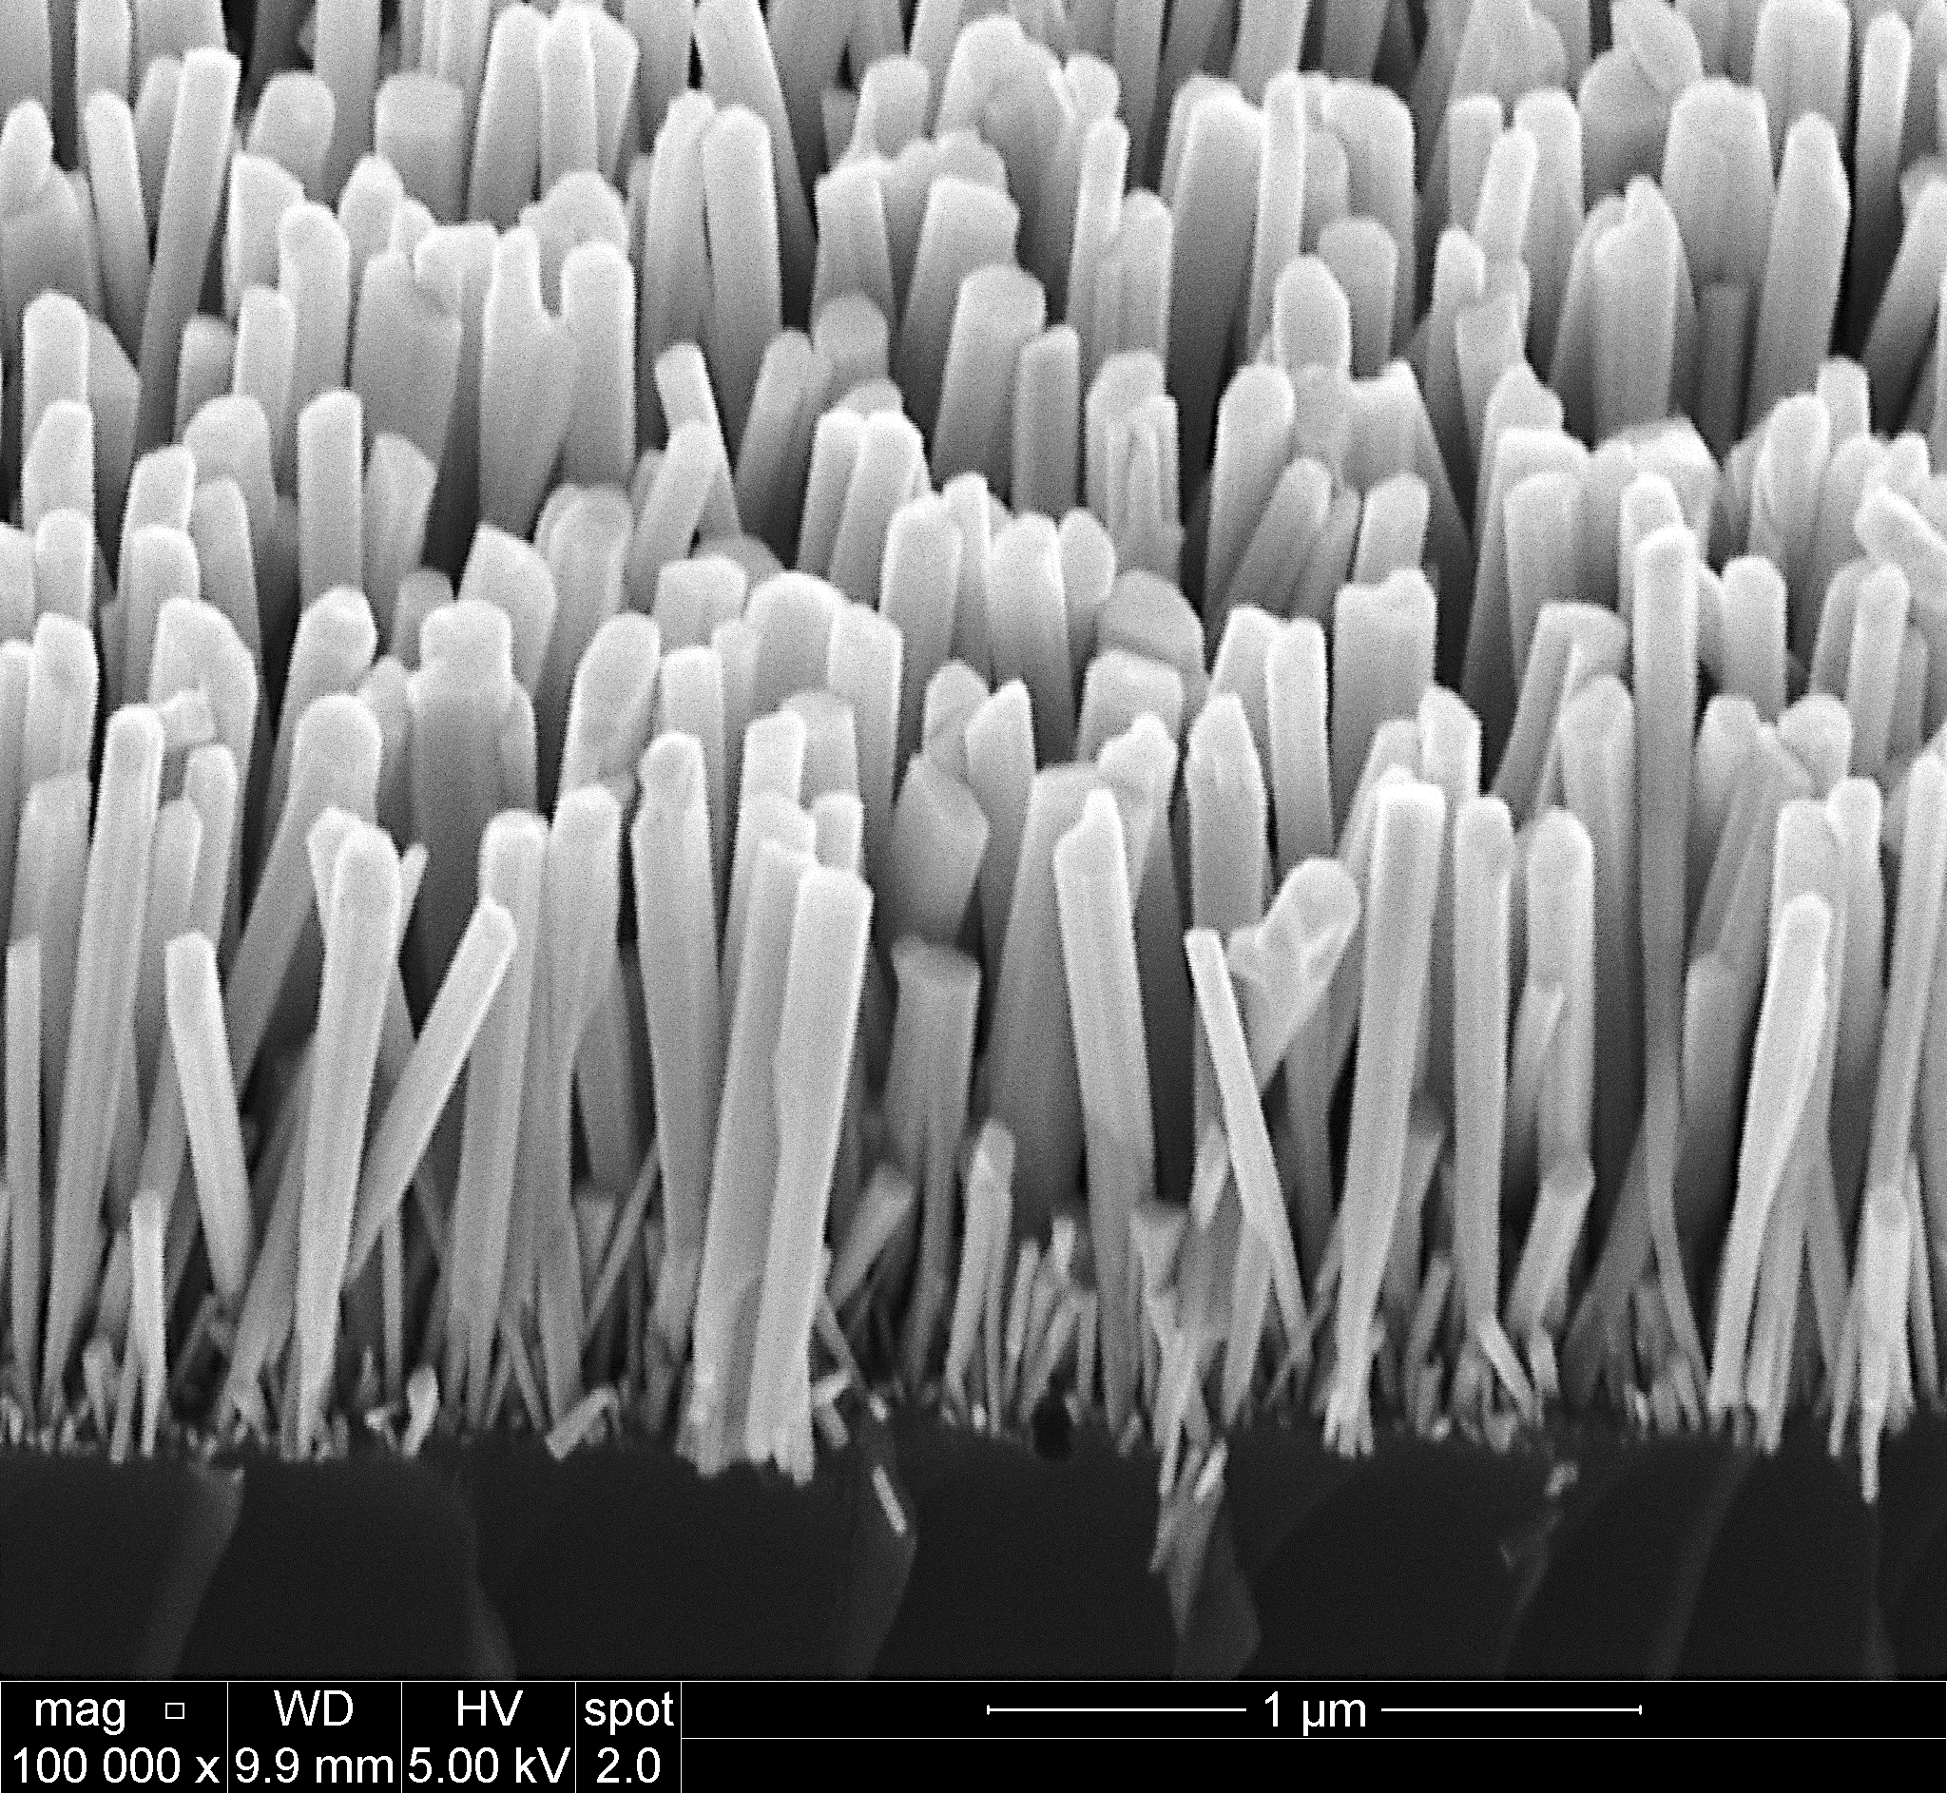

Figure 2. Scanning Electron Microscopy (SEM) of GaN NW grown from MBE.



(A) (B)

(C) (D)

(E) (F)

 

Figure 3. Catalyst performance examination. (A) Reaction setup and procedures. (B) Performance of catalyst with different doping. (C) Catalyst recyclability test. (D) Catalysts performance with quantification of surface area. (E) Large-scale benzene to toluene conversion. (F) Isotope labeling experiment.

(A) (B)

(C)



Figure 4. Reaction kinetic study and the proposed mechanism. (A) Kinetic study of benzene to toluene conversion. (B) Kinetic study of methanol-to-ethanol conversion. (C) Proposed mechanism involving two methanol molecules.

(A) (B)



Figure 5. Direct methane to toluene conversion. (A) Reaction equation. (B) Catalyst efficiency with different doping.